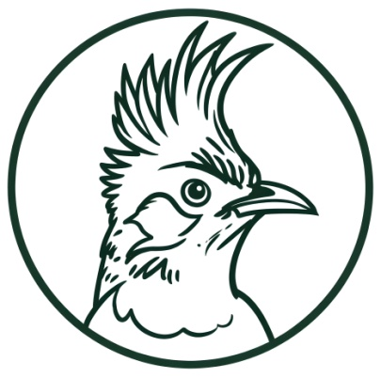
The_Birds_Vet
Trust of India

https://www.thebirdsvet.org.in/
Technical Advisory Board

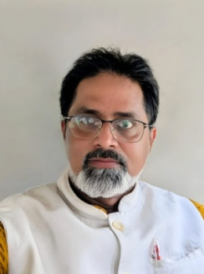
Dr. Sushant Srivastava
Senior Avian Reproductive & Breeding Consultant
Professor and Head
Department of Veterinary Gynaecology
and Obstetrics
CVSc&AH, Acharya Narendra Deva University Of Agriculture And Technology, Kumarganj, Ayodhya (UP) 224229

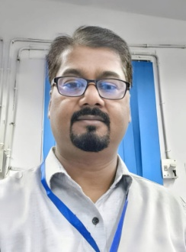
Dr. Rishikant
Senior Avian Health & Toxicology Consultant
Assistant Professor
Department of Veterinary Pharmacology and Toxicology
CVSc&AH, Acharya Narendra Deva University Of Agriculture And Technology, Kumarganj, Ayodhya (UP) 224229

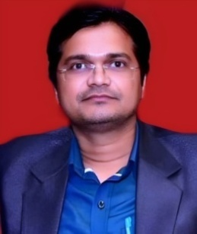
Dr. RP Diwakar
Avian Microbiology Consultant
Assistant Professor (SS)
Department of Veterinary Microbiology
CVSc&AH, Acharya Narendra Deva University Of Agriculture And Technology, Kumarganj,
Ayodhya (UP) 224229

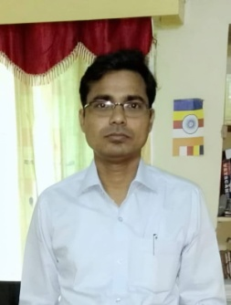
Dr. Rajesh Kumar
Associate Avian Reproductive & Breeding Consultant
Assistant Professor
Department of Veterinary Gynaecology
and Obstetrics
CVSc&AH, Acharya Narendra Deva University Of Agriculture And Technology, Kumarganj, Ayodhya (UP) 224229

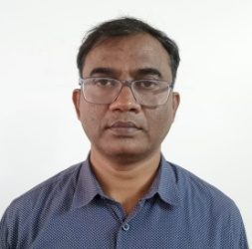
Dr. Laxmi Prasad
Aquatic Avian Conservation Consultant
Professor and Head
Department of Aquaculture
College of Fisheries Science, DUVASU, Mathura (UP) 281001


The_Birds_Vet
Trust of India

https://www.thebirdsvet.org.in/
Board Members
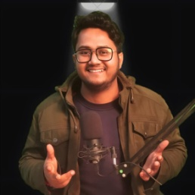
Mr Abhishek Verma
Technology Head & Admin

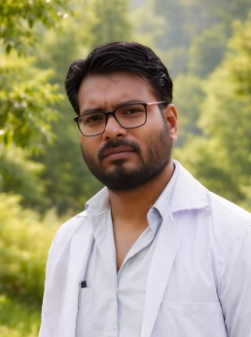
Dr. Anoop Kumar Shastri
Deputy Director

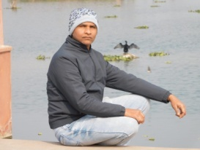
Mr Abhilash Verma
Bird Care Coordinator

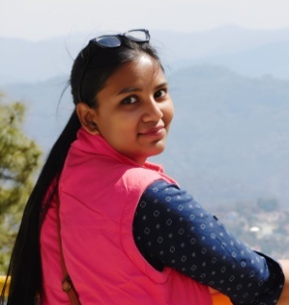
Shweta Verma
Aquatic Avian welfare Coordinator

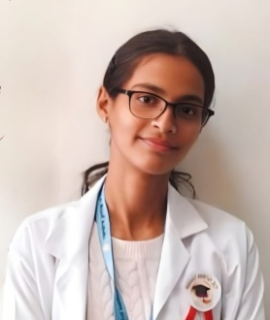
Anchal Verma
Avian Care Coordinator

